Palaeobiogeographical analysis for the late Viséan corals in the Variscan Realm of Western Europe and Northern Africa

Markus ARETZ

Université de Toulouse (UPS), GET (OMP), 14, Avenue Edouard Belin, 31400 Toulouse, France; markus.aretz@get.obs-mip.fr

The proximity of palaeobiogeographical units can be evaluated and correlated with the spatial distribution of benthic faunas. A case study is herein been presented for the late Viséan rugose corals of the European and African Variscan Realm.
The dataset on the species level comprises the well-studied coral faunas from both sides of the Rhenohercynian Basin in Belgium and SW Spain. Additionally the low diverse coral fauna of Nova Scotia (Poty 2002) has been added. In the southern Variscan domain of Europe late Viséan coral faunas are less well documented and described. For the purpose of this study published and unpublished data from the Montagne Noire, the Pyrenees and the Betic Cordillera were used. In Northern Africa late Viséan coral faunas are widely known, but currently the quality of taxonomic information is very heterogeneous (see discussion in Aretz 2010a). For the purpose of this study all available data have been compiled for the Moroccan Meseta and neighbouring palaeogeographical units and the Sahara Platform in Morocco and Algeria.
All these regions have been grouped into the Western European coral province by Sando (1990). Although representing a single palaeobiogeographical province, the distribution patterns of specific taxa within this province are very heterogeneous, e.g. Siphonodendron junceum and colonial axophyllids. This can only partly be explained by their adaptation to specific environments (Aretz 2010b) or the local lack of reliable data.
For this case study seven spatial units have been differentiated: Sahara Platform (Basins south of the South Meseta Fault), Meseta (representing the mobile Variscan Morocco), Ossa Morena, Nova Scotia, Belgium, Southern France (Montagne Noire and Pyrenees) and Betics (Malaguides and Baleares). The single units comprise very different environments and their sizes partly homogenise the lack of data.
Several statistical analyses show that three distinctive clusters existed in the Western European coral province sensu Sando (1990). These are (1) Belgium, Nova Scotia, Ossa Morena and Moroccan Meseta, (2) Sahara platform, and (3) southern France and SE Spain (Fig. 1).
The most isolated cluster is that of the southern European Variscan. A significant palaeobiogeographical barrier has to be proposed for the time slice and that should correspond to the central zones of the Variscan Orogen separating a northern and southern realm. It can further be concluded that two regions, which are geographical proximal in present days, were clearly separated in Variscan times, the Eastern Moroccan Meseta and the Malagides. The coral faunas of the Western and Eastern Moroccan Meseta are part of the ‘Rhenohercynian cluster’ and thus good indicators for the potential continuation of the European Variscan Zones into North Africa and the plate configuration at that time. The coral faunas of the Sahara Platform are much closer to the ‘Rhenohercynian cluster’ than to the southern European Variscides. This can be explained by minor faunistic and environmental differences between the stable cratonic basins south of the South Meseta Fault and the mobile zones of the Moroccan and European Variscides. However, the information of inter- and interspecific variabilities of the coral taxa in this region are badly known, and the number of endemic species (Semenoff-Tian-Chansky 1974) may be currently overestimated.
The data on corals are also supported from the data obtained for other benthic and pelagic macrofauna (brachiopods, ammonoids). The distribution of the calcareous algae Eovelibitella (Vachard et al. 2006) is a good example for the overlap with the Southern Variscan coral cluster, and thus shows that the coral clusters indicate more than environmental control or insufficant data.
More lines here
More lines here
More lines here
Last line on this page
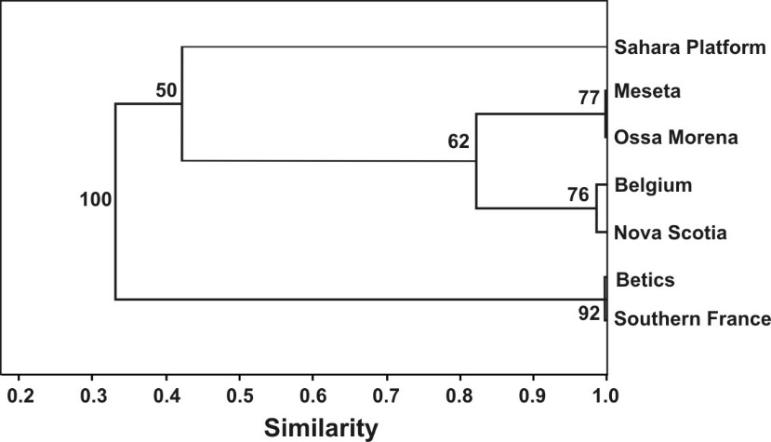

Fig. 1: Cluster Analysis (Raup-Crick Coefficent; node supports at 1000 bootstrap replicates) for the Western European coral province of Sando (1990). Seven spatial units of late Viséan coral faunas have been differentiated in Western Europe and Northern Africa.

More lines here
More lines here
More lines here
More lines here
More lines here
More lines here
More lines here
More lines here
More lines here
More lines here
More lines here
More lines here
More lines here
More lines here
More lines here
More lines here
More lines here
More lines here
More lines here
More lines here
More lines here

Aretz, M. (2010a): Rugose corals from the upper Viséan (Carboniferous) of the Jerada Massif (NE Morocco): taxonomy, biostratigraphy, facies and palaeobiogeography. - Paläontologische Zeitschrift, 84: 323-344.
Aretz, M. (2010b): Habitats of colonial rugose corals: the Mississippian (Carboniferous) of Western Europe as example for a general classification. - Lethaia, 43: 558-572.
Poty, E. (2002): Stratigraphy and paleobiogeography of Carboniferous Rugose Corals of Nova Scotia. – In: Hills, L.V., Henderson, C.M. & Bamber, E.W. (Eds.), Carboniferous and Permian of the world. Canadian Society of Petroleum Geologists, Memoir, 19: 580-587.
Sando, W.J. (1990): Global Mississippian coral zonation. - Courier Forschungsinstitut Senckenberg, 130: 173-187.
Semenoff-Tian-Chansky P. (1974): Recherches sur les Tétracoralliaires du Carbonifère du Sahara occidental. - Centre de Recherches des Zones arides, série: géologie, 21: 1-316.
Vachard, D., Pille, L., Aretz, M., Herbig, H.-G. & Cozar, P. (2006): Eovelebitella (dasyclad algae) and importance of its Brigantian subprovince within the western Palaeotethys. – In: Aretz, M. & Herbig, H.-G. (Eds.), Carboniferous Conference Cologne. From Platform to Basin, September 4-10, 2006. Program and Abstracts. Kölner Forum für Geologie und Paläontologie, 15: 120-121.
Last line here

